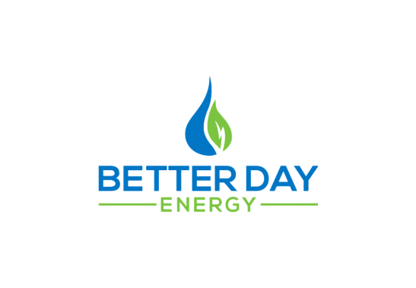
Customer Setup Document
Thank you for the opportunity to earn your business. Please tell us about your company.
BUSINESS NAME |  |  | DBA
BILLING ADDRESS |  |  | FEIN | STATE TAX ID | □ Sole Proprietor
CITY | STATE | ZIP | PHONE | FAX | □ Partnership
Est. Annual Volume Fuel |  | DIESEL | GAS |  | □ C-Corp □ S-Corp
Years in Business | # of Employees | Credit Amount Requested |  |  | □ LLC □ Other
Have you ever declared bankruptcy? □ Yes □ No |  | If Yes, Please Explain:

Please tell us about Principals with over 10% ownership. □ Additional Ownership Details Attached

Key Contacts: Purchasing & AP
FULL NAME |  | PHONE | FULL NAME |  | PHONE
TITLE | SOCIAL | DOB | TITLE | SOCIAL | DOB
PRIMARY RESIDENCE ADDRESS |  |  | PRIMARY RESIDENCE ADDRESS
CITY | STATE | ZIP | CITY | STATE | ZIP
PURCHASING MANAGER NAME | AP CONTACT NAME
PURCHASING EMAIL | AP EMAIL
PURCHASING PHONE | AP PHONE
Credit Terms
Customer understands and agrees that if open credit terms are approved by Better Day Energy, customer agrees to pay according to those terms.. Payment received after the due date is subject to a fee of $100 per day beyond the due date. Customer agrees to pay all costs and attorney fees incurred in collection of all past due invoices and accounts. Should any customer checks or ACH credit/debits be returned by their bank for the reason of insufficient funds, customer agrees to pay one hundred thirty-five dollars ($135.00) for each check as a handling charge. Claims arising from invoices must be made within five (5) working days. Customer certifies that the information presented by the customer in this application is true and correct. Better Day Energy is authorized to contact all references and banks contained in this application as well as credit reporting agencies in order to determine the credit worthiness of the customer.
The undersigned has read this Credit Application and agrees to the statements, terms and conditions stated herein.
NAME | TITLE | SIGNATURE | DATE

